**Task 5-Capture and Analyze Network Traffic**

**1.Install Wireshark**

Already installed on the system.

**2.Start capturing on your active network interface.**

* Capture->Start

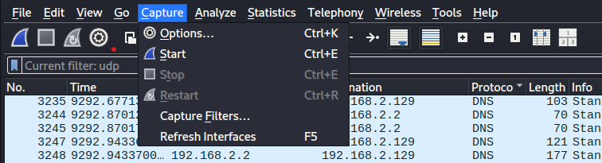

**3.Browse a website or ping a server to generate traffic.**

* <https://google.com>

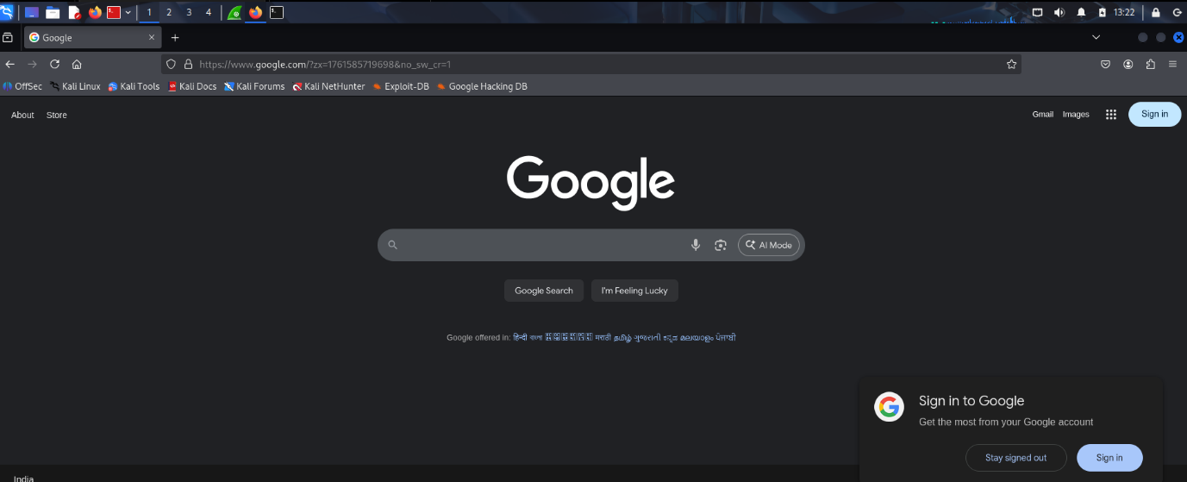

Captured packets generated by <https://google.com>.

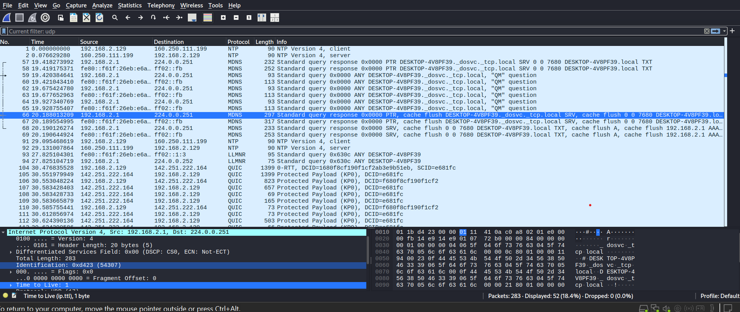

**4.Stop capture after a minute.**

**5.Filter captured packets by protocol(e.g., HTTP, DNS, TCP).**

* tcp

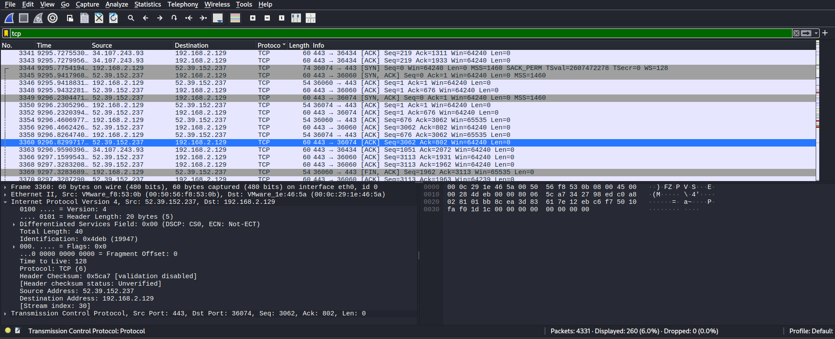

* http

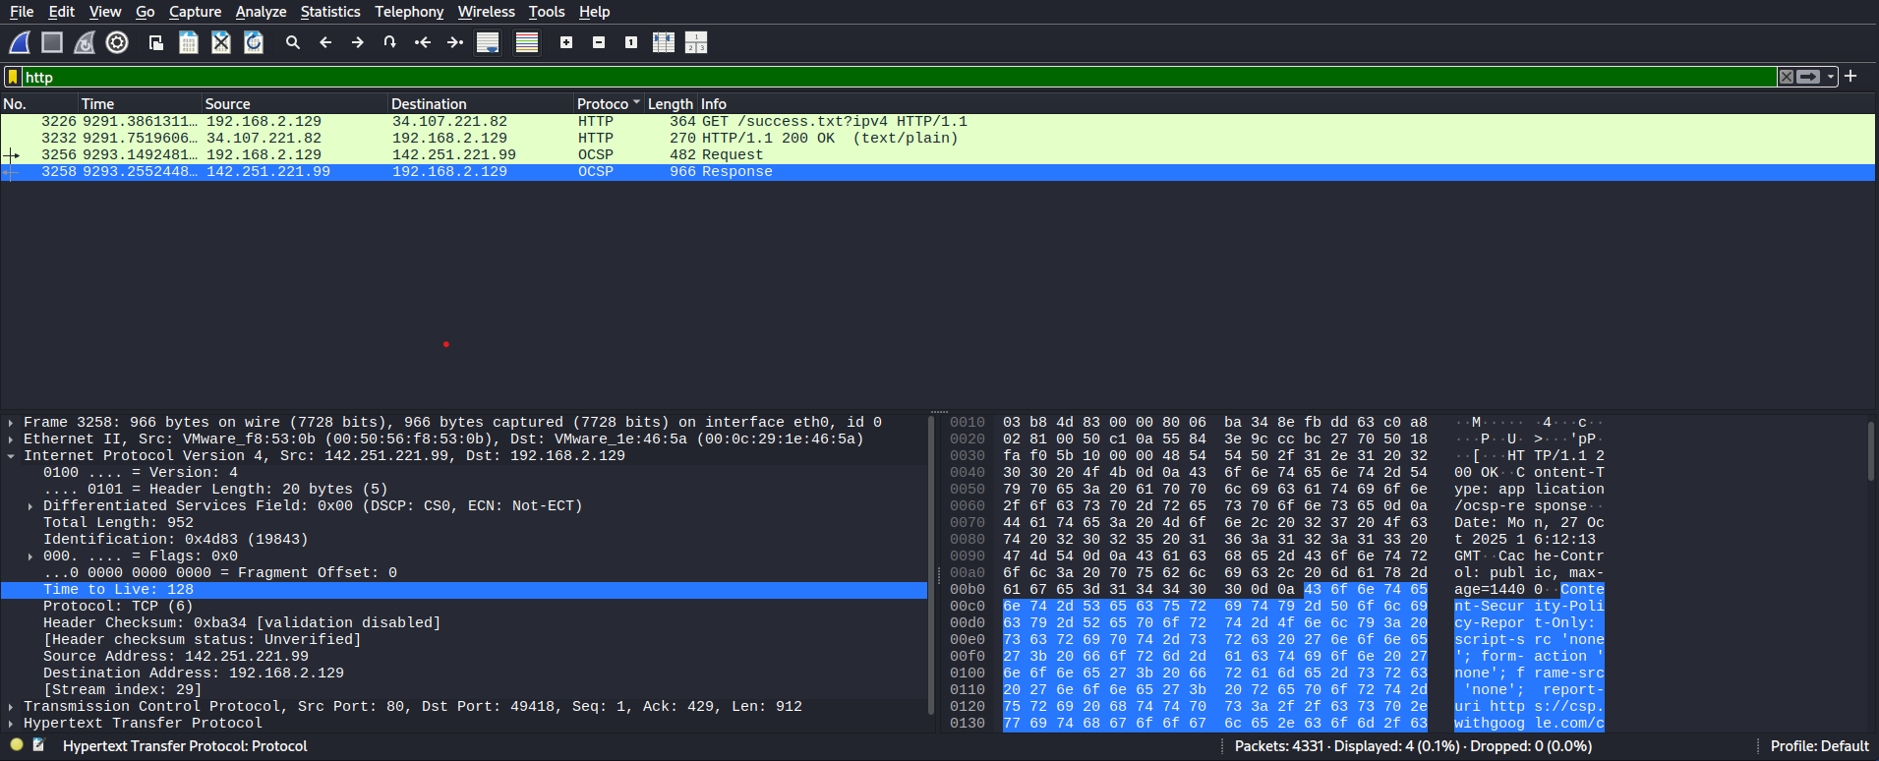

* dns

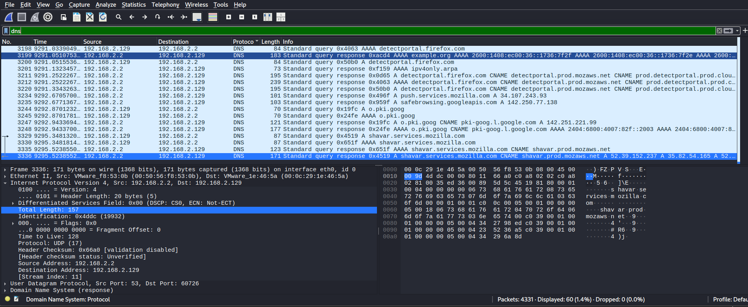

* tls

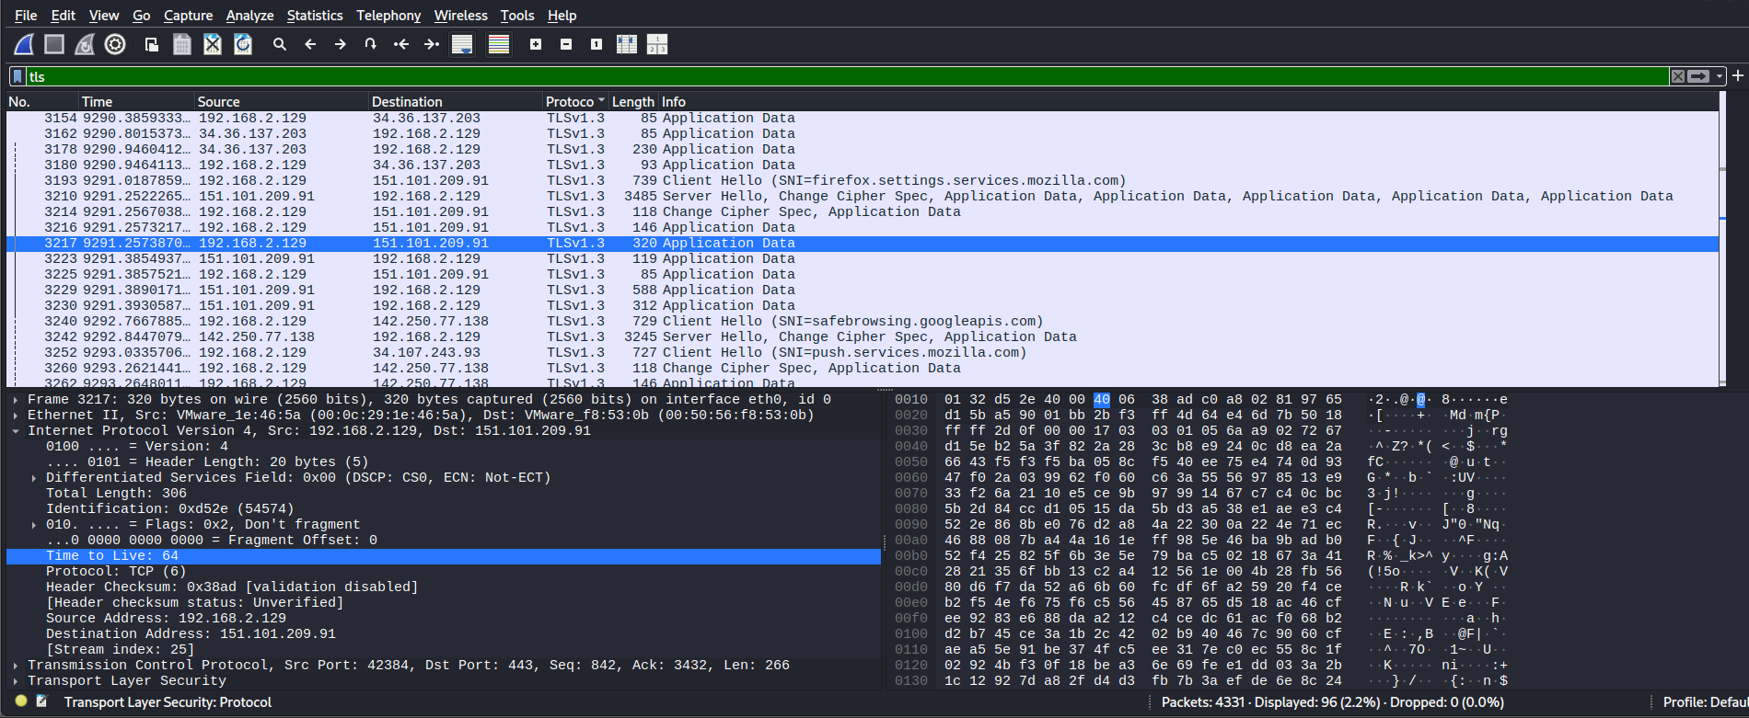

• **Interface:** eth0 (active network interface)

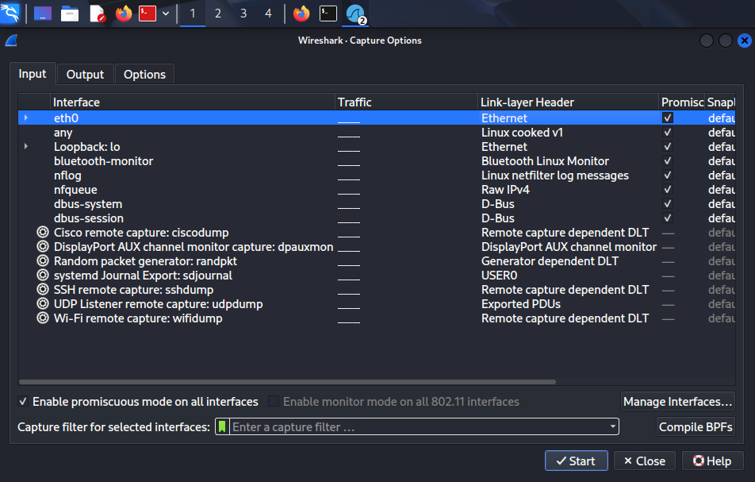

• **Protocols observed:**

**• NTP –** Network Time Protocol

**• MDNS –** Multicast DNS

**• LLMNR –** Link-Local Multicast Name Resolution

**• QUIC –** Quick UDP Internet Connections (encrypted HTTP/3 traffic)

• **Source / Destination:**

* 192.168.2.1 → 224.0.0.251 (Multicast, typical for MDNS)

• **Ports:** UDP 5353 → used by MDNS

**6.Identify atleast 3 different protocols.**

* NTP
* MDNS
* LLMNR
* QUIC